Question 1: Checkout Time Reduction
A product manager at a food delivery app wants to evaluate whether a new checkout flow reduces the time taken to place an order. The same 10 users were observed before and after the checkout redesign.
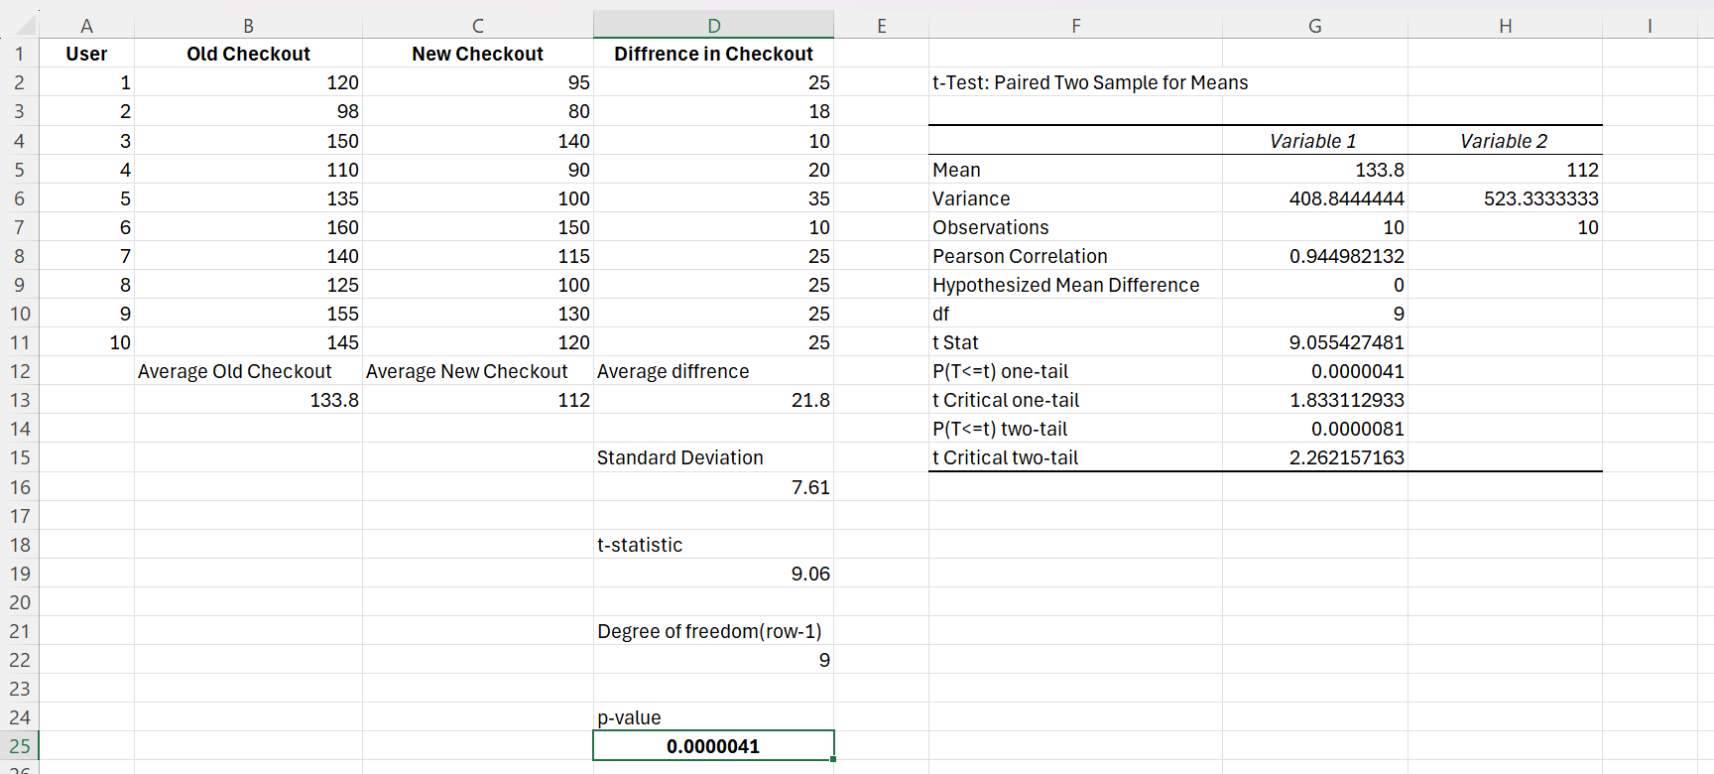
1.Null and Alternative Hypotheses
Null Hypothesis (H₀):
There is no difference in the mean checkout time before and after the redesign.
$$H_{0}:μ_{\text{old}}=μ_{\text{new}}$$
Alternative Hypothesis (H₁):
The new checkout flow reduces the mean checkout time.
$$H_{1}:μ_{\text{old}}>μ_{\text{new}}$$
2.Statistical Test Used and Justification
Test Used: Paired t-Test
Justification:
The same set of users was observed before and after the checkout redesign. Since the observations are dependent (paired) and the variable measured is continuous (time in seconds), a paired t-test is the appropriate statistical test.

3.Test Performed Using Excel
The paired t-test was performed using Excel Analysis ToolPak
(Data → Data Analysis → t-Test: Paired Two Sample for Means)
4. Results
- Mean Checkout Time (Old Checkout): 133.8 seconds
- Mean Checkout Time (New Checkout): 112.0 seconds
- t-statistic: 9.0554
- p-value (one-tailed): 0.0000041 (p < 0.001)

5.Conclusion
Since the p-value is significantly less than the significance level of 0.05, the null hypothesis is rejected.
Therefore, it is concluded that the new checkout flow significantly reduces checkout time.

Question 2: Device Type vs Purchase Intention
An e-commerce company wants to determine whether device type influences purchase intention.
1.Problem Understanding
An e-commerce company wants to check whether device type (Mobile/Desktop) influences purchase intention (Purchased / Did Not Purchase). Both variables are categorical.
2.Null and Alternative Hypotheses
Null Hypothesis (H₀):
Purchase behaviour is independent of device type.
(Device type has no influence on purchase intention)
Alternative Hypothesis (H₁):
Purchase behaviour is dependent on device type.
(Device type influences purchase intention)

3.Statistical Test Used and Justification
Test Used: Chi-Square Test of Independence

Justification:
- Both variables (device type and purchase outcome) are categorical
- Data is in the form of frequencies
- The test checks whether two categorical variables are related
Therefore, the Chi-Square Test of Independence is appropriate.
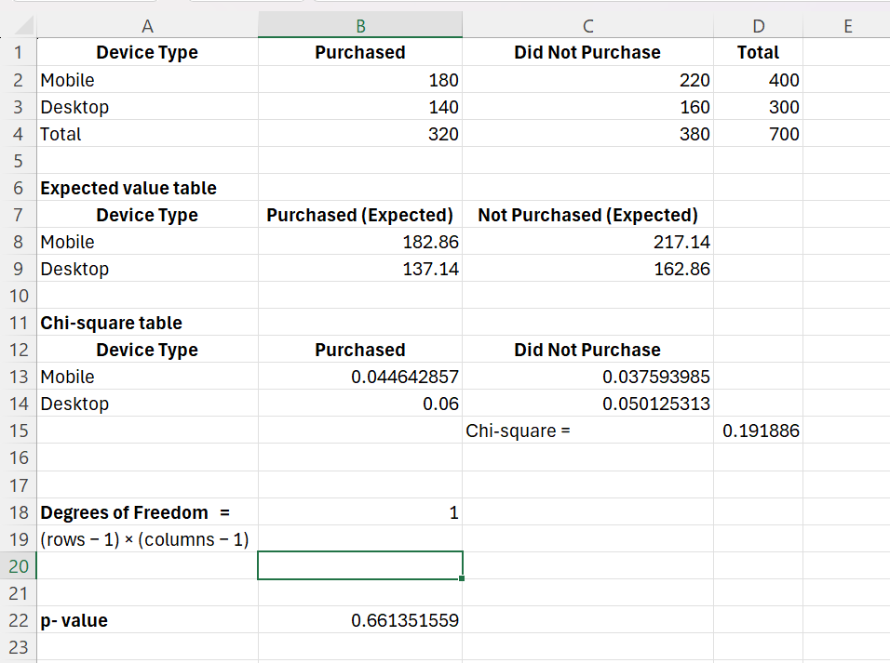

4. Interpretation of Results
Is purchase behaviour dependent on device type?
The p-value obtained from the Chi-Square Test of Independence is 0.661, which is greater than the significance level of 0.05. Therefore, the null hypothesis is not rejected. This indicates that purchase behaviour is not statistically dependent on device type. In other words, there is no significant relationship between the device used (Mobile or Desktop) and whether a user makes a purchase.

Based on observed proportions, which device performs better?
The observed purchase proportions are:
- Mobile: 180 purchases out of 400 users → 45% conversion rate
- Desktop: 140 purchases out of 300 users → 46.7% conversion rate
Although desktop users show a slightly higher purchase conversion rate compared to mobile users, the difference is not statistically significant. Hence, neither device can be concluded to perform significantly better in terms of purchase behaviour.

Question 3: Watch Time Comparison
A streaming platform tests whether premium users watch more content per day compared to free users. Daily watch time (in minutes) was recorded for two independent groups.

Problem Statement
A streaming platform wants to test whether premium users watch more content per day than free users. Daily watch time (in minutes) is recorded for two independent groups.

Null and Alternative Hypotheses
Null Hypothesis (H₀):
The mean daily watch time of free users and premium users is the same.
$$H_{0}:μ_{\text{free}}=μ_{\text{premium}}$$
Alternative Hypothesis (H₁):
Premium users watch more content per day than free users.
$$H_{1}:μ_{\text{premium}}>μ_{\text{free}}$$

Statistical Test Used and Justification
Test Used: Independent Samples t-Test (Two-Sample t-Test)
Justification:
- The two groups (free and premium users) are independent
- The variable measured (watch time in minutes) is continuous
- The objective is to compare means of two independent groups
Therefore, an independent samples t-test is appropriate.

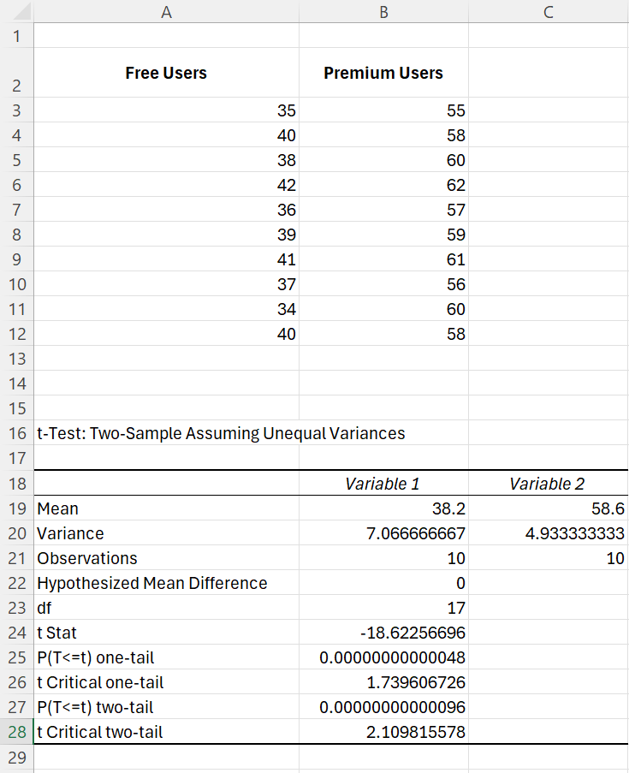

Since the p-value is significantly less than(p=0.000000000000048<0.05) , the null hypothesis is rejected.
Premium users watch significantly more content per day compared to free users.

Question 4: Landing Page A/B Test
A SaaS company is testing a new landing page to improve signup conversion rate. An A/B test was conducted for one week.

1.Null and Alternative Hypotheses
Null Hypothesis (H₀):
The signup conversion rate of Variant B is equal to that of Variant A.
$$H_{0}:p_{A}=p_{B}$$
Alternative Hypothesis (H₁):
The signup conversion rate of Variant B is greater than that of Variant A.
$$H_{1}:p_{B}>p_{A}$$

2.Statistical Test Used and Justification
Test Used: Z-Test for Two Proportions
Justification:
- The outcome (signup / no signup) is binary
- The objective is to compare conversion rates (proportions) of two independent groups
Therefore, a Z-test for proportions is appropriate.

Results
- Conversion Rate (Variant A): 8.0%
- Conversion Rate (Variant B): 9.0%
- Pooled proportion: 8.53%
- Z-statistic: 1.6475
- p-value (one-tailed): 0.0497
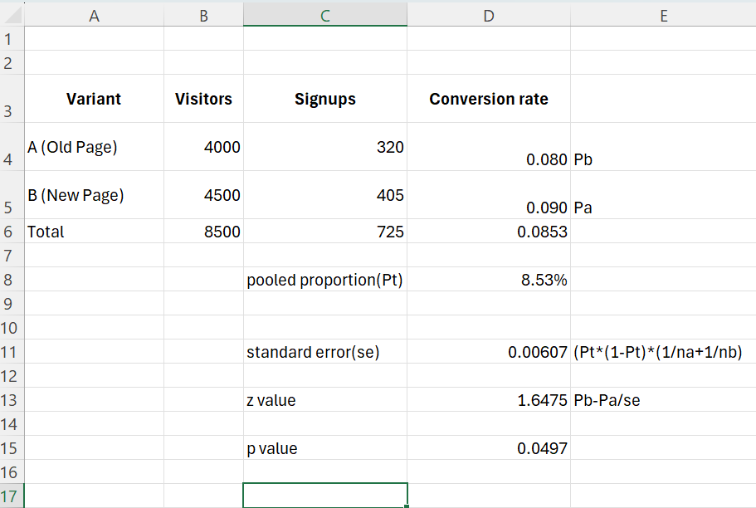

Conclusion
Since the p-value (0.0497) is less than the significance level of 0.05, the null hypothesis is rejected.
Therefore, Variant B (new landing page) performs significantly better than Variant A in terms of signup conversion rate.

Based on the A/B test results, it is recommended that the company roll out the new landing page (Variant B).

